Correspondence Analysis

- When to use Correspondence analysis?
Correspondence analysis reveals the relative relationships between and within two groups of variables, based on data given in a contingency table. For brand perceptions, these two groups are brands and the attributes that apply to these brands. For example, let’s say a company wants to learn which attributes consumers associate with different brands of beverage products. Main example is that correspondence analysis helps measure similarities between brands and the strength of brands in terms of their relationships with different attributes. Understanding the relative relationships allows brand owners to pinpoint the effects of previous actions on different brand related attributes, and decide on next steps to take.
CA requires the data to have the same scale (all questions must have some possible answers). Moreover, CA is a descriptive tool and doesn’t give p-values per se

- How does CA work?

- CA takes a series of categorical variables and converts them to a contingency table (a count of the number of responses at each level for each variable)
- It then uses the chi-squared distribution to convert the data into a series of factors (you can specify the number of factors)
- These factors are designed to be minimally correlated with each other
- The first factor represents the most variation/inertia in the data and the following ones less so
- It takes a large number of variables and maps them on to a smaller number of variables. Very similar to Principle Component Analysis (PCA)

- Example as how to run CA

Step to conduct CA
Step 1: Create contingency table
Step 2: Run the CA
Step 3: Visualize the CA (symmetric)
Step 4: How many axes do we keep?
Step 5: Interpreting axes
Step 6: Evaluating quality of fit
Step 7: Clustering the results

Step 1: Create contingency table

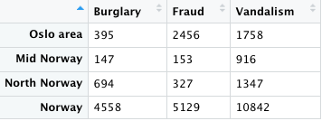

The data have been taken from Criminal Statistics 1984 (Statistics Norway, 1986) and show a cross-classification of crimes investigated by the police and different areas in Norway. Data were available for the entire country, but for illustrative purposes only three areas are shown. Likewise, only three types of all crimes investigated are shown: burglary, fraud, and vandalism. The advantages of the method are greatest, however, when it is used to analyze large tables.

Step 2: Run the CA

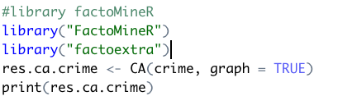

The results of CA
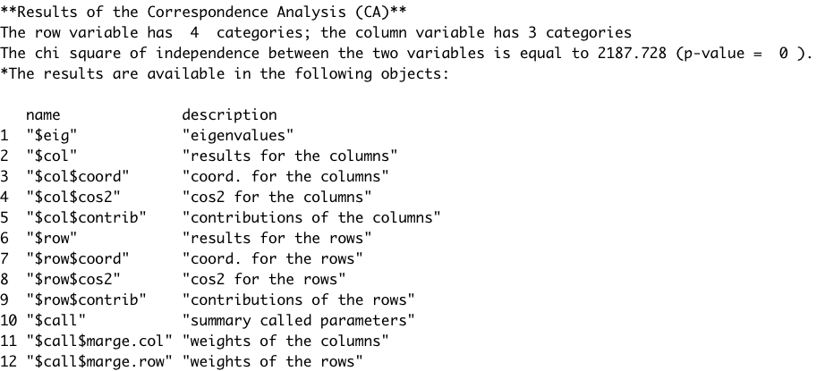
Understand the chi-square result

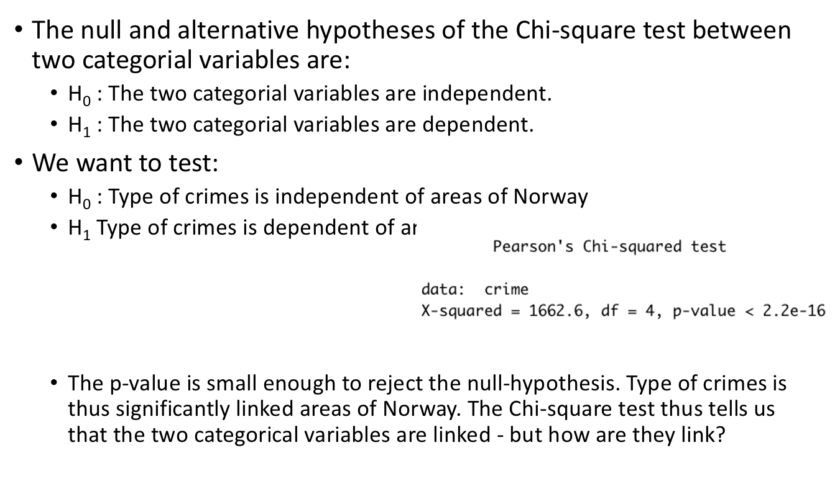

Step 3: Visualize the CA (symmetric)

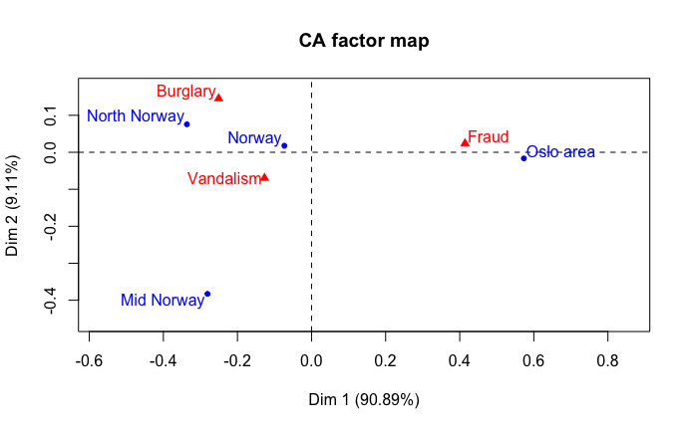

Interpret the plot
We see that the point that represents the whole country lies in the direction of mid Norway and north Norway. This means that these two parts of the country have profiles relatively similar to the profile for the country as a whole, whereas Oslo is more atypical.

Step 4: How many axes do we keep?

- The CA created many possible axes, but only some are helpful
- Each axis has an eigenvalue that tell us how much information it explains (larger eigenvalue, more info)
- If the data were completely random, we’d expect each axis to have an eigenvalue of 1/(nrow()-1) or 1/(4-1)=1/3=33% for rows, and 1/(ncol()-1) or 1/(3-1)=1/2=50% for columns
- If eigenvalues are less than the largest of these two values, then should be kept, else can be ignored (though can keep it but will add little)
- For us, we look for eigenvalues 50% or greater

Exploring Eigenvalues

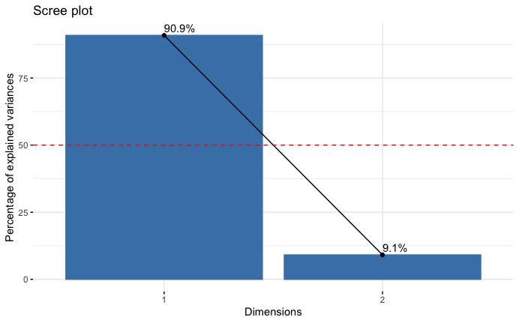

Step 5: Interpreting axes

- The axes of the CA are not always immediately interpretable
- To better understand them, we look at which columns and which rows contributed the most to the creation of that axis
- We only need to explore axis 1
Contribution of columns

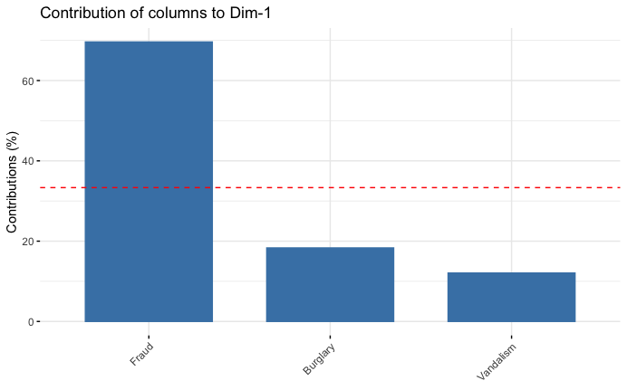

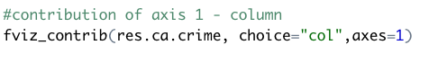

Fraud contributed strongly to axis 1
Fraud is also on opposite sides to Burglary and Vandalism
Positive values of axis 1 correlate with more Fraud and negative values with more Vandalism and Burglary

Contribution of rows

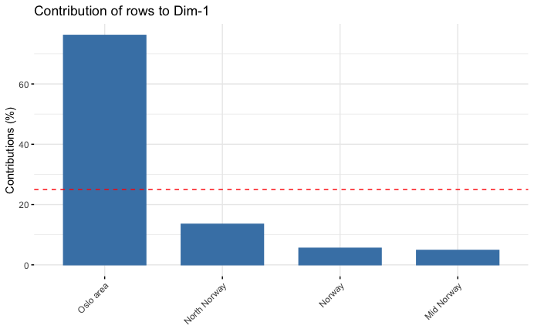

Step 6: Evaluating quality of fit

- After determining the number of axes to retain and what they mean, we need to see how well each row and column item is represented by the retained number of dimensions
- The squared cosine (cos2) is a measure of the quality of representation
- cos2 values range from 0 to 1 and values close to 1 indicate a good representation and 0 a very bad representation

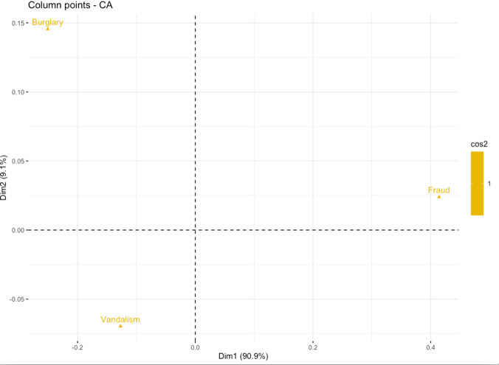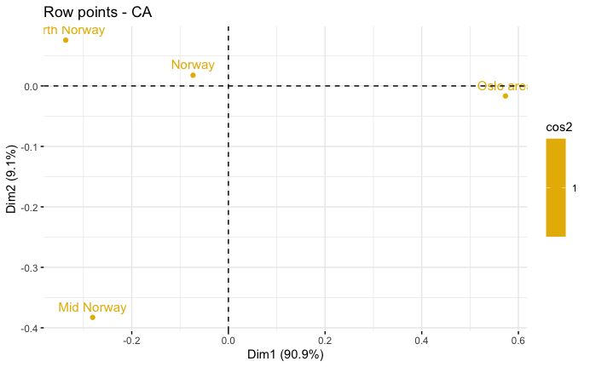

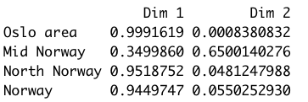

Rows Norway, Mid, Olso, North Norway have the highest quality of fit for rows
Columns Vandalism, Burglary, Fraud have the highest quality of fit for columns
That means no extra axes is needed to explain them

In case, rows that have the lowest quality of fit for rows
In case, columns that the lowest quality of fit for columns
That means that extra axes would better explain them

Step 7: Clustering the results

In this case there is no cluster due to a small dimensionality of contingency table. We skip this step.

Can use USArrest dataset to visualize cluster

Step 8: Interpretation of results

- Overall axis 1 indicates domains with more Fraud selections (positive values) or more Vandalism selections (negative values)

- North and Mid Norway occur on the same side with Norway.

BENEFIT OF USING CORRESPONDENCE ANALYSIS
We discussed the uses and benefits of correspondence analysis, and walked through the set up and calculations for correspondence analysis, culminating with creating our first standard correspondence analysis plot (shown below).



Summary
In conclusion, correspondence analysis is used to analyze the relative relationships between and within groups; in our case, these groups would be brands and attributes.
Correspondence analysis eliminates a skew in results from different masses between groups by utilizing indexed residuals.

Correspondence analysis is useful when you have a table with at least two rows and two columns, no missing data, no negative values, and all the data has the same scale.
When the study variables of interest are categorical, CA is an appropriate technique to explore relationships amongst variable response categories.

For brand perceptions for correspondence analysis, we utilize row principal (or column principal if the brands are placed on the columns) normalization, as this allows us to analyze relationships between different brands by their proximity to one another, and also allows us to analyze relationships between brands and attributes by their distance from the origin combined with the angle between them and the origin (the dot product), at the sacrifice of misrepresenting the relationship between attributes with exaggerated distances (which doesn’t matter to us as we don’t care about the relationships between attributes). We utilize the scaled row/column principal normalization to make it easier to analyze our graph at no cost. We want to make sure to keep in mind that we add up the variance explained from the X and Y axis labels (the first and second dimension) to view the total variance captured in the map; the lower this number is, the more unexplained variance there is in the data, and the more misleading the plot.
A last thing to remember is that correspondence analysis only shows relativities since we eliminated the mass factor of our data; our graph will tell us nothing about which brands have the ‘highest’ scores in attributes. Once you understand how to create and analyze the graphs, correspondence analysis is a powerful tool that disregards brand sizing effects to deliver powerful and easy to interpret insights about relationships both between and within brands and their applicable attributes.
References:
- https://www.qualtrics.com/eng/correspondence-analysis-what-is-it-and-how-can-i-use-it-to-measure-my-brand-part-1-of-2/
- https://rentzb.github.io/post/ca/
- https://www.ncbi.nlm.nih.gov/pmc/articles/PMC3718710/

